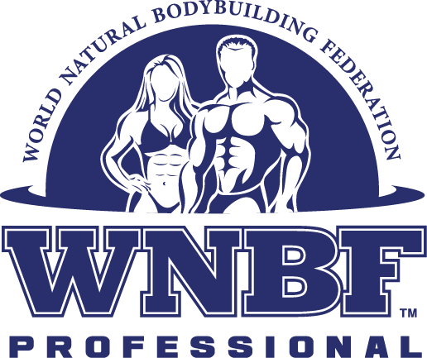

2022 WNBF PRO NATURAL US CUP EXTRAVAGANZA

BODYBUILDING, FIGURE & FIT BODY CHAMPIONSHIPS

Saturday, August 20th, 2022– New Haven, CT

ELIGIBILITY: All athletes must hold an active WNBF Pro Card. Athletes must not have used anabolic steroids, diuretics, prescription drugs for bodybuilding purposes, or other banned substances per their perspective time frames. Failure to sign any liability, drug-testing, or any other release form or waiver associated with this event, failure to pay necessary fees, or testing positive in either exam, will result in the forfeiture of the right to participate or receive prize money and loss of WNBF eligibility for a duration of 10 years.

TESTING: All athletes will be polygraph tested to ensure they are ten (10) Years drug-free. Urine testing will also occur.
POLYGRAPH TEST: Will be performed at the contest hotel prior to the day of the event. Fee is payable at time of exam (cash $75). URINE TEST: Prize money winners will be tested immediately after they come off stage.
* All WNBF Professionals are subject to random urine testing the day of the show, and at any time on or off season throughout the calendar year.

IT IS REQUIRED THAT YOU RETURN THE PRO US CUP EXTRAVAGANZA CONTRACT WITH YOUR ENTRY AND FEE.
SCHEDULE: Pre-Judge: 9:30 am
Mandatory Pro Athlete meeting Friday night – Location: FUL FIT LLC – 232 A Captain Thomas Blvd West Haven, Ct. 06516 - 7:00 PM.
PRO DIVISIONS – Entry Fee $175
Place an (X) in front of the division you wish to enter.

( ) Pro Men Bodybuilding: 2 Classes - 1st - $500, 2nd - $400, 3rd - $200
$1000 For Overall Male winner
( ) Pro Bikini: 1 Class- 1st -$1000, 2nd $400, 3rd $200
( ) Pro Men Physique 1 Class - 1st $1000, 2nd-$400, 3rd $200

These two classes will need 5 applicants to have these classes

( ) Pro Women Bodybuilding: 1 class - 1st - $1000, 2nd - $400, 3rd - $200

( ) Pro Figure 1 Class - 1st - $1000, 2nd - $400, 3rd - $200

*Prize money payouts may be adjusted based on class size
*5+ contestants in a class receive full prize payouts
Check/Money Order Payable to FUL FIT LLC
6 University Place
New Haven, CT 06511

*If you are not a current member of the WNBF, you must first purchase your WNBF Pro Card at WorldNaturalBB.com

ENTRY FEE DEADLINE: Entries must be RECEIVED no later than Saturday the, August 6th, 2022

NAME: (Print) __________________________. AGE: ___. PHONE: ______________.
ADDRESS: ________________. CITY: __________. STATE: ________. ZIP: _______.
GYM/TRAINER REP: ________________________
WNBF CARD EXPIRATION DATE: ________.
E-MAIL: ______________________________.
SIGNATURE: ____________________________. DATE: ______.
What show/year did you compete in to qualify for WNBF Pro Status: ____________________.
WAIVER: In consideration of your accepting this entry, I hereby intend to be legally bound for myself, my heirs, executors, and administrators and waive and release any and all rights and claims for damages I may have against the Promoter: Robert Fulton, WNBF/ INBF Officials: Bob Bell, Nancy Andrews, Tina Smith, and any and all of their sponsors, agents, representatives and assignees for any and all injuries and/or losses suffered by me as a result of my participation and/or attendance at the WNBF PRO NATURAL US CUP EXTRAVAGANZA, August 20th, 2022.

WORLD NATURAL BODYBUILDING FEDERATION

2022 WNBF PRO NATURAL US CUP EXTRAVAGANZA

BODYBUILDING, FIGURE & FIT BODY CHAMPIONSHIPS

COMPETITORS CONTRACT

I, _____________________________, agree to compete in the 2022 WNBF PRO NATURAL US CUP EXTRAVAGANZA

BODYBUILDING, FIGURE & FIT BODY CHAMPIONSHIPS which will be held on Saturday, August 20th, 2022. I understand that I am responsible to attend the Judging and Show of the competition, and participate in all scheduled mandatory drug testing that is required for my participation in the WNBF PRO NATURAL US CUP EXTRAVAGANZA BODYBUILDING, FIGURE & FIT BODY CHAMPIONSHIPS. I am also responsible to attend any meetings, publicity functions (photo shoots, interviews, media meetings, seminars, etc.) deemed necessary by the WNBF to promote the competition. If I fail to attend any mandated activities, I will forfeit my entry fees and may be suspended from membership and participation in WNBF events for a period of two (2) years from the contest date, plus I will be forced to re-qualify for the WNBF from the WNBF amateur ranks after the suspension time is served, should I wish to rejoin the WNBF. Further, I agree to give my full cooperation and release all rights with regards to the photography and editorial coverage of this contest for use in any other publications authorized by the WNBF. Failure to cooperate will result in a suspension from the WNBF. If, after returning this Contest Contract, I fail to compete for any reason other than a medical problem or emergency, for which I must submit verifiable proof from my personal physician to the WNBF, I will be suspended from membership and competition within the WNBF for two (2) years from the contest date. If my medical report is deemed to be insufficient, I agree to an examination by a physician assigned by the WNBF at my own expense. If my subsequent medical report is deemed invalid, will result in my suspension from the WNBF for two (2) years from the contest date. Failure to sign and return this contract to the WNBF by the entry deadline (August 6th, 2022) will result in my removal from the competition.

ACCEPTED AND AGREED:

SIGNATURE: ________________________________________ DATE: ____________

