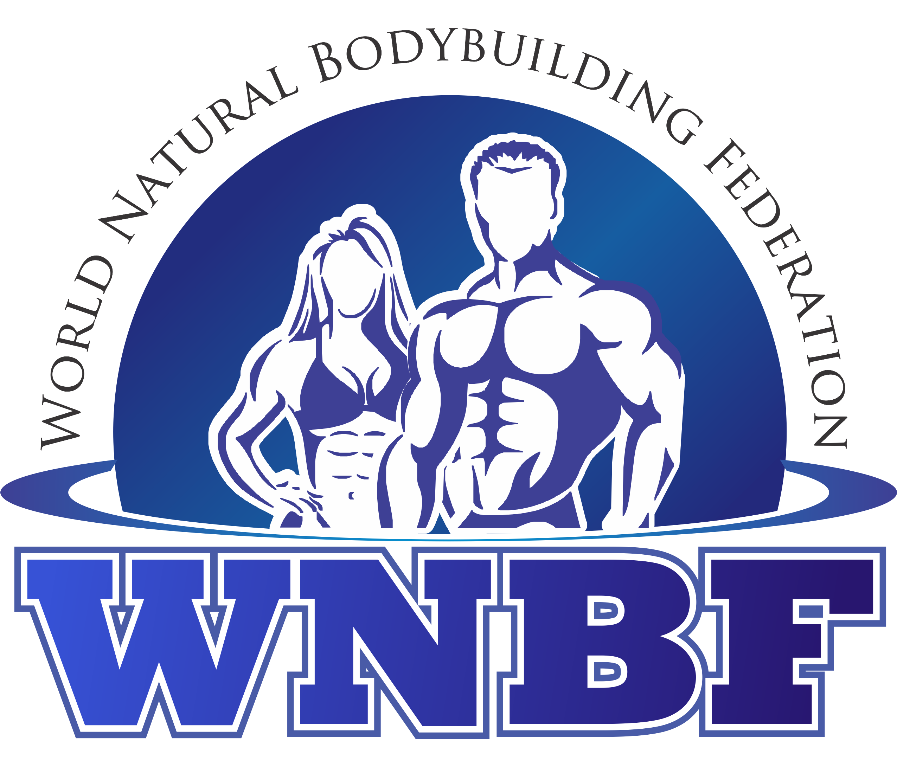
2016 WNBF NATURAL AUTUMN
EXPLOSION
,Saturday, October 1st 2016

James Hillhouse High School,

480 Sherman Parkway, New Haven CT
Check In-9:00 AM Prejudging: 12:00 PM
Evening Show Time 5:00 PM.
PRO-QUALIFIER

ELIGIBILITY: Open to all amateur athletes who possess a current WNBF card ($60.00) or who obtain one the day of the show. Athletes must be drug free for 7 years from the date of show.
FEES: Entry fee: $60.00 Crossover each extra class $30.00 Polygraph testing: $55.00
AWARDS: 1st five places in each weight class and overall. Figure 1st to 5th place.
MUSIC: CD must be preset to a maximum of 60 seconds.
ENTRY DEADLINE: September 26th, 2016. LATE FEE $50.00 NO REFUNDS!

DIVISIONS: (Check All That Apply)
OPEN MEN: ( ) Lightweight-150 ¼ to 165 lbs ( ) Bantam weight up to 150
( ) Middleweight-165 ¼ lbs to 176lbs ( ) TEENAGE
( ) Lt Heavyweight-176 ¼ to 190 lbs ( ) JUNIORS ages 20-24
( ) Heavyweight- Over 190 ¼ lbs
MASTERS MEN: ( )40 MASTERS ( )50 + GRANDMASTERS MEN PHYSIQUE: Short Up to 5’7( ) Tall 5’7 ¼ ( )

OPEN WOMEN BB: ( ) Lightweight-under 118 lbs. ( ) Heavyweight 118 lbs. &over. ( ) MASTERS WOMEN over 40
WOMEN FIGURE: ( ) 40 MASTERS FIGURE ( ) MS. FIT BODY ( ) Bikini S__M__T__ ( ) Master Bikini
OPEN FIGURE ( ) Short Class: Up to 5'3" ( ) Medium Class: 5' 3 1/4 and up ( ) Tall Class: 5' 7 and up
TODAY’S TOTAL FEES: CLASSES $____ CROSSOVER FEE $___ MEMBERSHIP $______ GRAND TOTAL$______
NOVICE MEN: ( ) NOVICE WOMEN BB: ( ) NOVICE FIGURE: ( ) NOVICE BIKINI: ( )
Definition: 1- Has not placed in top 3 in an open weight, in any organization.
2- Has not placed 1st in a novice contest, in any organization.
3- A Novice Competitor can not crossover to the open division.

Please Print: Name: __________________________________________________AGE ________________________
Telephone # Day ( )______________________________ Night ( )_____________________________________
ADDRESS _______________________________________________________________________________________
CITY__________________________________________STATE___________ZIP______________________________
E Mail:___________________________________________________________________________________________
GYM OR TRAINER REPRESENTING________________________________________________________________
INBF membership #____________________________EXPIRATION DATE:_________________________________
Previously tested within 90 days?_____Yes ____What WNBF Show?__________________________________________

TITLES WON:____________________________________________________________________________________

WAIVER: In consideration of your accepting this entry, I hereby intend to be legally bound for myself, my heirs, executors and administrators and waive and release any and all rights and claims for damages I may have against the James Hillhouse High School, World Natural Bodybuilding Federation, Inc. (WNBF), Robert J. Fulton & FUL FIT LLC and any sponsors, agents, representatives and assigns for any injures and/or losses suffered by me as a result of my participation and/or attendance at the 2016 WNBF Autumn Explosion Championships Saturday October 1st, 2016. I understand that, in order to compete in a WNBF-sanctioned event, I will be required to submit to up two (2) drug tests to validate a seven-year abstinence from the use any type steroids, hormones, pro hormones, prescription diuretics and any and all other compounds deemed illegal by the decision of the WNBF concerning my participation in an WNBF -sanctioned contest pending the results of one or both tests, as well as my adherence to all WNBF rules and regulations. Failure to pass WNBF drug tests or failure to adhere to WNBF rules and regulations will result in my expulsion from the competition in question, as well as loss of WNBF eligibility for seven years. I also agree to submit to any and all out-or-season testing required by INBF and agree to stand by the results of said testing, whatever it may be.

SIGNATURE ___________________________________________________DATE____________________________
SIGNATURE OF PARENT OR GUARDIAN (IF UNDER 18).___________________________________________
*Certified Bank Check or Money Orders to: FUL FIT LLC , 6 University place New Haven CT, 06511

